Image’s Objects Detection

Chuong Nguyen

CST-451 Capstone Project Proposal

Grand Canyon University

Instructor: Professor Mark Reha

Revision:

Date: 11/11/2018

**ABSTRACT**

The human can recognize the objects easily in the image. With the development of photography technology, there are massive number of images need to process. It is necessary to have algorithms to analyze data on the images. Object detection is an important part of images processing. It has been researched, developed and used in various industries. Object detection is applying widely in manufacture, traffic control, security ...

My application creates an application to detect objects in images and videos. From application, user input image and the object detection algorithm will return the objects in the image. All the images and objects will be saved into the database. Then users can search the images in the database. The application let the user input multiple images in the same time and find the images which contain specific input objects. The application can detect objects from stream video, and capture the stream video with its object.

Users can use this application in traffic monitoring. For example, the cameras at an intersection take a lot of pictures. An officer wants to find pictures of cars that passed through the red light. He can input all the images that were taking that day and search the images that contain cars and red light. After that, the officer can decide if he needs to send a ticket to the driver.

**Project Records**

|  |  |  |
| --- | --- | --- |
| **Date** | **Author** | **Revision Notes** |
| 09/15/2018 | Chuong Nguyen | Project Proposal |
| 10/15/2018 | Chuong Nguyen | Design Phase v1.0: Rough Draft Design |
| 12/15/2018 | Chuong Nguyen | Design Phase v2.0: Final Design |
| 02/10/2019 | Chuong Nguyen | Project Development and Implementation |
| 03/04/2019 | Chuong Nguyen | Testing Phase. |
| 04/10/2019 | Chuong Nguyen | Project Completion, |

|  |
| --- |
| **Overall Instructor Feedback/Comments**  Create functions to search images contains specific objects from multiple images  Draw bounding box for the object in the image. And let the users choose which object they want to draw. |

|  |
| --- |
| **Overall Instructor Feedback/Comments** |

**Integrated Instructor Feedback into Project Documentation**

Yes  No

**Project Approval**

Professor Isac Artzi

**TABLE OF CONTENTS**

Project Overview and Project Objectives 5

Project Scope 6

Project Success Measures 8

Project High-Level Solution 9

Project Controls 10

Project Cost and Schedule 12

Appendix A – References 14

Appendix B – Copyright Compliance 15

Project Overview and Project Objectives

The goal of this project is create an web application that can detect the objects from images, classify images, detect objects from stream video, search and draw a specific objects from images or video.

**State the Problem and Background**

Image processing is very important in self-driving car, security monitoring, health care images’ processing… A self-driving car has a complicated system of camera and sensor to capture the objects around and make decision how to drive immediately. Security monitoring needs to detect objects’ image to identify risks. A tracking system capture images of text and need to decode it to text. Image processing has been researched and applied in real life.

**Project Objectives**

* Classify objects in the image and the video
* Localize objects in the image and the video
* Count objects in the image and the video
* Search the images with input objects’ name
* Save image data into database and retrieve in user’s purposes.

**Challenges**

The project use TensorFlow pre-trained model to classify objects, by presenting a lot of images’ data. pro

Developer doesn’t have experiences with TensorFlow and Python’s application

Developer is not familiar with install environment for TensorFlow API on cloud

**Benefits and Opportunities**

This application can be applied in real life. This is the most important role in self-driving car industry.

This application can be applied for industrial where workers need to input manually data from picture or processing image. It will save time, labor and cost. Human-computer interaction (face id)

This application can be applied in many area: Robotics, Electrics, Security (recognition, tracking), Retrieval (search engine, photo management), Transportation

Project Scope

1. Give a clear, concise statement that states the scope of the project. This should also include items that are to be out of scope.

On Scope:

* Make a high accuracy object detection application. This application can detect, localize, and counting real object.
* This application can be applied in real life. For example, detect a real object (human, things…)
* Deploy model on real time device (camera, raspberry pi)

Out of Scope:

* Model cannot evaluate the objects after detection.
* Implement model on Smart phone is another option to test model but it is not required
* Deploy the application on cloud

1. Use the template to list all known stakeholders and contacts, if applicable, including self (for some projects self may be the only name listed)

|  |  |  |
| --- | --- | --- |
| Stakeholder Name | Role(s) | Responsibilities |
| Chuong Nguyen | Owner | Documentation, Design, Program and Testing |

1. List the work breakdown required to satisfy the project objectives. Identify teams and other resources that may be required to successfully complete the project.

|  |  |  |  |  |  |  |  |  |  |  |
| --- | --- | --- | --- | --- | --- | --- | --- | --- | --- | --- |
| Work Breakdown Structure | | | | | | | | | | |
| ID | Task | Dependencies | Status | Effort Hours | Cost | Start Date | Planned Completion | Estimate to Completion | Actual Completion | Resource |
| 1 | Ideas plan |  |  | 1 weeks |  | 08/28/18 | 08/30/18 | 08/30/18 | 09/05/18 |  |
| 2 | Discuss with mentor |  |  | 1 weeks |  | 08/30/18 | 09/05/18 | 09/05/18 | 09/05/18 |  |
| 3 | Brain storm |  |  | 1 weeks |  | 09/05/18 | 09/10/18 | 09/10/18 | 09/10/18 |  |
| 4 | Research |  |  | 1 month |  | 09/10/18 | 10/10/18 | 10/10/18 | 10/10/18 |  |
| 5 | Design |  |  | 1 month |  | 10/11/19 | 12/15/18 | 12/15/18 | 12/15/18 |  |
| 6 | Implementation |  |  | 3 month |  | 01/10/19 | 03/15/19 | 03/15/19 | 04/10/19 |  |
| 7 | Testing |  |  | 1 month |  | 03/10/19 | 04/10/19 | 04/10/19 | 04/11/19 |  |

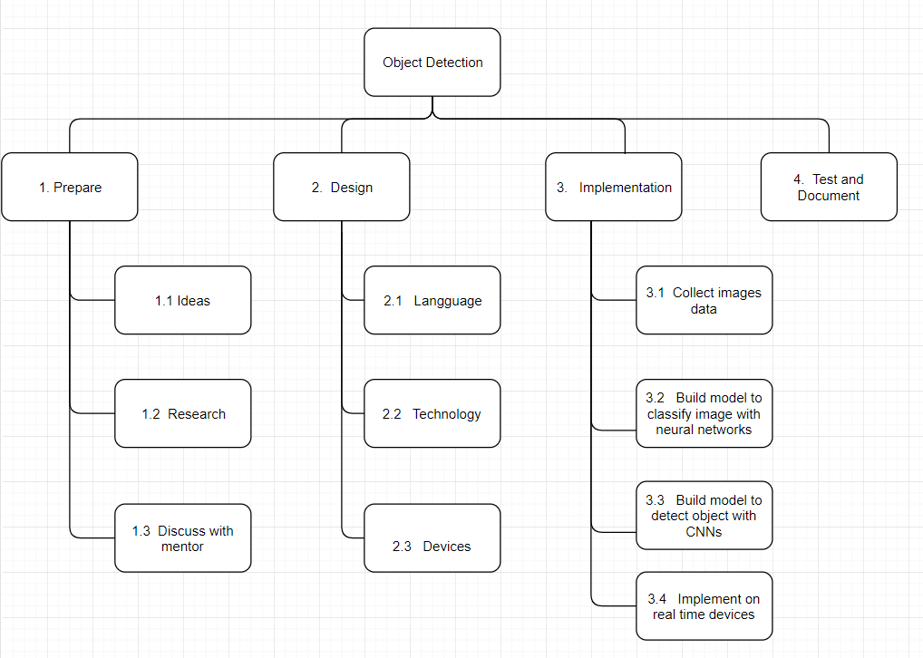

Project Success Measures

1. Project measures.

* Accuracy of object detection
* Performance of algorithm
* Ability to apply in real world

1. Project completion criteria.

|  |
| --- |
| Project Completion Criteria |
| 1 – Project can run and detect object correctly |
| 2 – Finish on time |
| 3 – Application easy to deploy |

1. Project assumptions and constraints

|  |  |  |  |  |  |  |
| --- | --- | --- | --- | --- | --- | --- |
| Assumptions and Constraints | | | | | | |
| ID | Description | Comments | Type | Status | Date Entered |
| 1 | TensorFlow is become popular and there are more resources to research | There are many tutorials and documentation, source code that can use for references | Assumption |  |  |
| 2 | There are many pretrained models for object detection | These pretrained model RCNN, Fast RCNN, YOLO.... can help to detect an image. | Assumption |  |  |
| 3 | Solution to integrate to devices (Raspberry Pi camera, camera phone…) | Need to find a solution to test on devices | Constrains |  |  |
| 4 | Programming language | Programmer is not familiar with python language and machine learning | Constrains |  |  |

**Project High-Level Solution**

**Introduction**

The idea of the application is to create a web server using Python and Flask. JavaScript, HTML is used for the front-end. A TensorFlow Object Detection API which uses MobileNet Object Detection Model Architecture is called from Flask server to detect objects in the image and video. MySQL is used for the database.

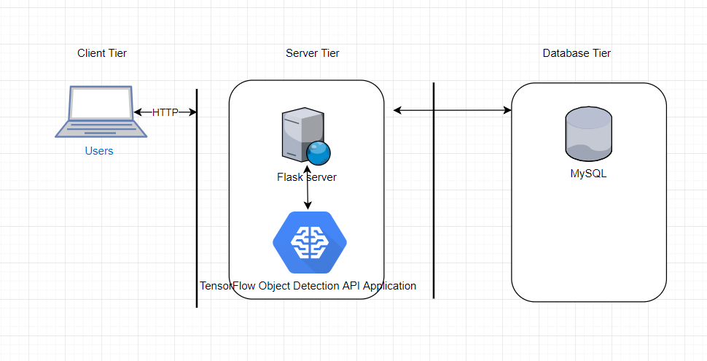

**Solution**

Create Flask web server, and call TensorFlow Object Detection API to detect the objects from the image. TensorFlow is an open source machine learning library developed by Google. A python application running on Flask server will provide an Object Detection API service for object detection. Image after detection returns the instances of objects and their location in the image. The object’s detail is wrapped up in a JSON object and store into a MySQL database.

**Project Controls**

|  |  |  |  |  |
| --- | --- | --- | --- | --- |
| Risk Management | | | | |
|  | **Risk Probability** | **Risk Impact** |  |  |
| **Event Risk** | **(high, medium, low)** | **Risk Mitigation** | **Contingency Plan** |
| Using open library and open source | high | Violate Copyright | Limit use unnecessary open sources | Citation all resources |
| Programming language | Medium | Impact time to finish project | Practicing | Follow project schedule.  Use project management methodology. |
| Run application on device | Medium | Cannot test application in real time | Run project on visual system | Prepare back up devices, solution |

|  |  |  |  |  |  |  |  |  |
| --- | --- | --- | --- | --- | --- | --- | --- | --- |
| Issues Log | | | | | | | | |
| **ID** | **Description** | **Project Impact** | **Action Plan/Resolution** | **Owner** | **Importance** | **Date Entered** | **Date to Review** | **Date Resolved** |
| 1 | What is the issue? | How will this impact scope, schedule & cost? | How do you intend to deal with this issue? | Who manages this issue? |  |  |  |  |
| 2 | Need performance GPU to run the model efficiently | It might affect performance of application, | Integrate GPU into CPU | Chuong Nguyen | Important | 09/09 |  |  |
| 3 | Objects training image is not enough | It might affect the accuracy of application | Collect large data images | Chuong Nguyen | Important | 09/09 |  |  |

**Change Log**

|  |  |  |
| --- | --- | --- |
| **Date** | **Author** | **Revision Notes** |
| 09/15/2018 | Chuong Nguyen | Project Proposal  The idea is creating an application for image detection using Machine Learning |
| 10/15/2018 | Chuong Nguyen | Design Phase v1.0: Rough Draft Design |
|  |  | The application will use Python, TensorFlow API, Flask serve, and MySQL database |
| 12/15/2018 | Chuong Nguyen | Design Phase v2.0: Final Design  The application will use Python, TensorFlow API, Flask serve, and MySQL database. The application will be deployed on AWS. |
| 02/10/2019 | Chuong Nguyen | Project Development and Implementation |
|  |  | The project does not use the MVC architecture due to the Flask framework’s architecture.  The project cannot implement on AWS due to TensorFlow environment and video stream detection. The project is deployed and demo on localhost.  Add function let user search from multiple images. Result are only the images which contain input objects from user. |
| 03/04/2019 | Chuong Nguyen | Testing Phase. |
| 04/10/2019 | Chuong Nguyen | Project Completion, |

|  |  |  |  |
| --- | --- | --- | --- |
| Roles and Responsibilities | | | |
| Name | Team | Project Role | Responsibility |
| Chuong Nguyen |  | Owner | Plan, Design, Programmer, Testing, Documentation |
|  |  |  |  |

**Project Cost and Schedule**

|  |  |
| --- | --- |
| Cost | |
| Material | Price |
| CPU 2.2GHZ x 8GB GPU x 16GB RAM | Personal laptop |
| Real time device (laptop camera, Raspberry pi) | Laptop webcam |  |  |

1. Create a project schedule after all project tasks have been defined and prioritized.

|  |  |  |  |  |  |  |  |  |  |
| --- | --- | --- | --- | --- | --- | --- | --- | --- | --- |
| Project Schedule | | | | | | | | | |
| ID | Task | Sept | Oct | Nov | Dec | Jan | Feb | March | April |
| 1 | Ideas plan | X |  |  |  |  |  |  |  |
| 2 | Discuss with mentor | X |  |  |  |  |  |  |  |
| 3 | Brain storm | X |  |  |  |  |  |  |  |
| 4 | Research |  | X |  |  |  |  |  |  |
| 5 | Design |  | X |  |  |  |  |  |  |
| 6 | Implementation |  |  | X | X | X | X |  |  |
| 7 | Testing |  |  |  |  |  |  | X | X |

1. Set a programming schedule by implementing work breakdown and task time estimates. Create a timeline with dates for completion of key components of the project.

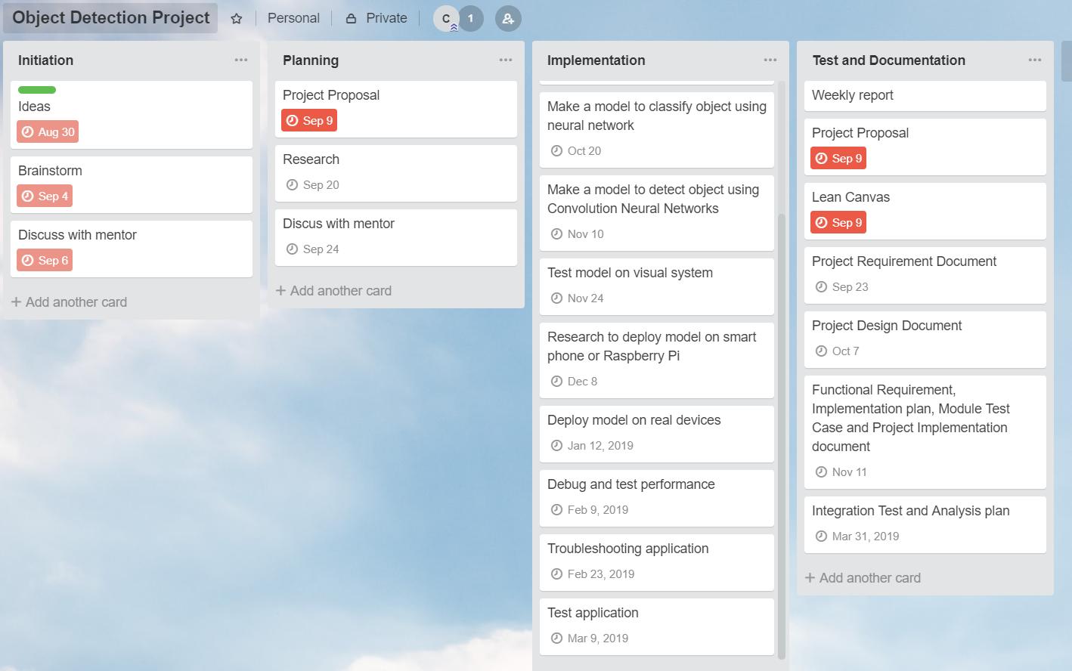

Appendix A – References

*List all references using APA style*

1. [Prince, Grover](https://towardsdatascience.com/@pgrover3?source=user_popover). Evolution of Object Detection and Localization Algorithms. Retrieved from

<https://towardsdatascience.com/evolution-of-object-detection-and-localization-algorithms-e241021d8bad>

# Image Classification using Deep Neural Networks — A beginner friendly approach using TensorFlow. Retrieved from

<https://medium.com/@tifa2up/image-classification-using-deep-neural-networks-a-beginner-friendly-approach-using-tensorflow-94b0a090ccd4>

1. Andrew, Ng. Convolutional Neural Networks.

<https://coursera.org>

Appendix B – Copyright Compliance

Python: free software license

TensorFlow: opensource library developed by Google.

OpenCV: free open source Python library under open source BSD license